**Class Activity: Room Database – Step by Step Solution**

**\*\* Due to version issue, the Java solution provided is in API 34, need to run with API 34 emulator devices as well.**

1. Create a new project with the following configuration,
   1. Empty Views Activity
   2. Language: Java
   3. Minimum API level: API 21: Android 5.0 (Lollipop)

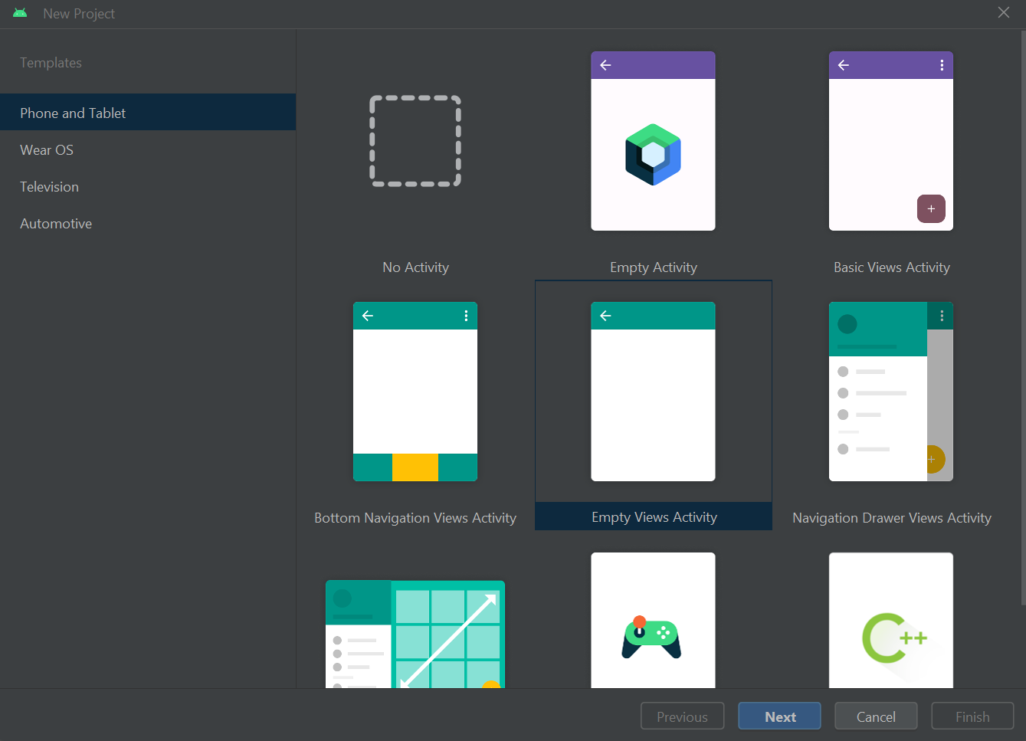

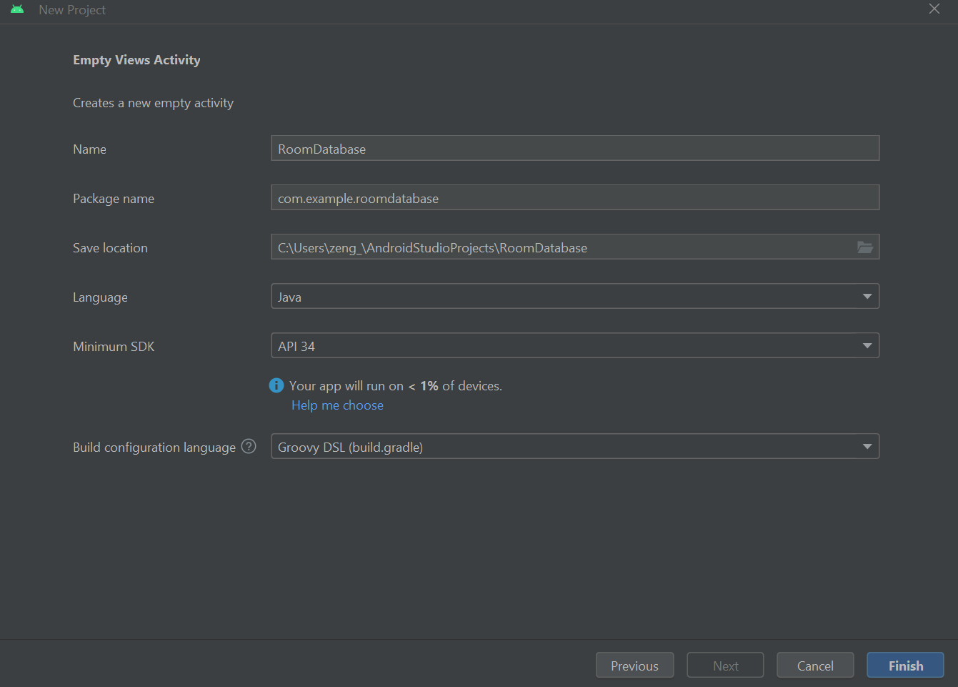

1. Add the Gradle dependencies.
   1. Open build.gradle file for your module from here.

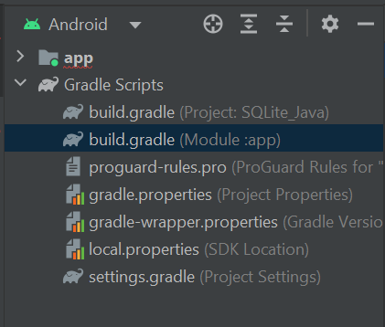

* 1. Add the following dependencies.

| implementation "androidx.room:room-runtime:2.6.0"  annotationProcessor "androidx.room:room-compiler:2.6.0" |
| --- |

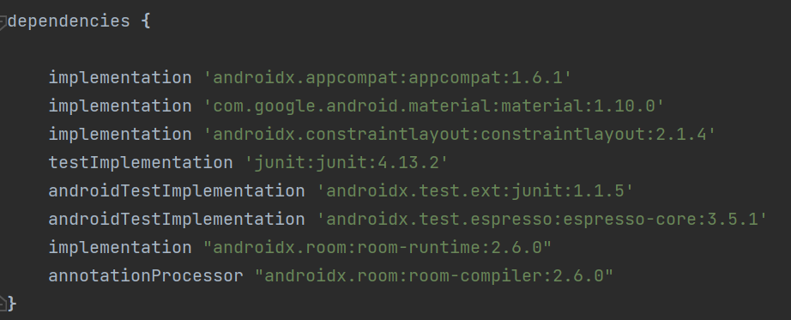

1. Create the layout of your main activity according to the figure shown below.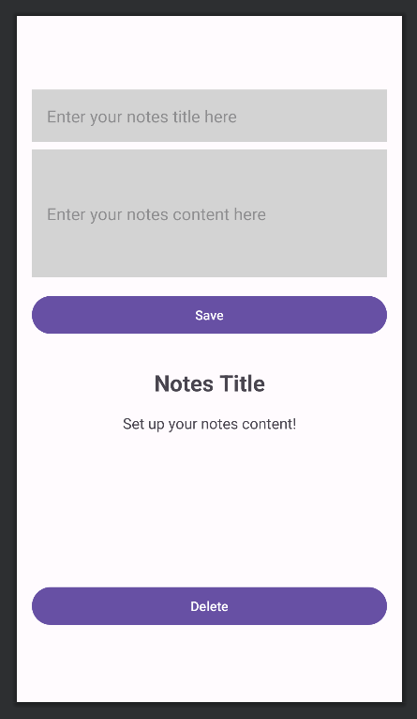

Create 2 EditText here to allow user input for notes title and notes content. The background colour used here is #D3D3D3. Remember to use the “textMultiLine” input type for notes content EditText.

Create a button here to save the user input into Room database.

Create 2 TextView here to display the notes title and notes content. The default text to display for title is “Notes Title” and “Set up your notes content!” for content.

Create a button here to delete the notes from Room database.

| <?xml version="1.0" encoding="utf-8"?>  <LinearLayout  xmlns:android="http://schemas.android.com/apk/res/android"  xmlns:app="http://schemas.android.com/apk/res-auto"  xmlns:tools="http://schemas.android.com/tools"  android:layout_width="match_parent"  android:layout_height="match_parent"  android:orientation="vertical"  android:padding="16dp"  android:gravity="center"  tools:context=".MainActivity">  <EditText  android:id="@+id/editTitle"  android:layout_width="match_parent"  android:layout_height="wrap_content"  android:background="#d3d3d3"  android:padding="16dp"  android:layout_marginBottom="8dp"  android:hint="Enter your notes title here" />  <EditText  android:id="@+id/editContent"  android:layout_width="match_parent"  android:layout_height="136dp"  android:background="#d3d3d3"  android:layout_marginBottom="16dp"  android:padding="16dp"  android:hint="Enter your notes content here"  android:lines="5"  android:inputType="textMultiLine" />  <Button  android:id="@+id/saveButton"  android:layout_width="match_parent"  android:layout_height="wrap_content"  android:layout_marginBottom="32dp"  android:padding="8dp"  android:text="Save" />  <TextView  android:id="@+id/notesTitle"  android:layout_width="match_parent"  android:layout_height="wrap_content"  android:layout_marginBottom="8dp"  android:paddingBottom="8dp"  android:text="Notes Title"  android:textAlignment="center"  android:textSize="24sp"  android:textStyle="bold" />  <TextView  android:id="@+id/notesContent"  android:layout_width="match_parent"  android:layout_height="wrap_content"  android:layout_marginBottom="32dp"  android:paddingBottom="128dp"  android:text="Set up your notes content!"  android:textAlignment="center"  android:textSize="16sp" />  <LinearLayout  android:layout_width="match_parent"  android:layout_height="wrap_content"  android:orientation="horizontal"  android:gravity="center">  <Button  android:id="@+id/deleteButton"  android:layout_width="match_parent"  android:layout_height="wrap_content"  android:text="Delete"  android:padding="8dp" />  </LinearLayout>  </LinearLayout> |
| --- |

1. Create Data Entity for Note class based on the class diagram below. Create Note class in a separate file called *Note.java*.

| Note |
| --- |
| - id: int  - title: String  - content: String |
| + Note()  + Note(id: int, title: String, content: String)  + setId(id: int)  + getId(): int  + setTitle(title: String)  + getTitle(): String  + setContent(content: String)  + getContent(): String |

| package com.example.roomdatabase;  import androidx.room.PrimaryKey;  import androidx.room.Entity;  @Entity(tableName = "notes")  public class Note {  @PrimaryKey  private int id;  private String title;  private String content;  public Note() {  }  public Note(int id, String title, String content) {  this.id = id;  this.title = title;  this.content = content;  }  public void setId(int id) {  this.id = id;  }  public int getId() {  return this.id;  }  public void setTitle(String title) {  this.title = title;  }  public String getTitle() {  return this.title;  }  public void setContent(String content) {  this.content = content;  }  public String getContent() {  return this.content;  }  } |
| --- |

1. Create Data Access Objects (DAOs) for Note class, called *NoteDao.java*.

Inside NoteDao interface, create void insert(Note note), void delete(Note note) and Note getNoteById(int id). Use the @Insert annotation for insert(Note note), @Delete annotation for delete(Note note) and @Query annotation for getNoteById(int id) where you will need to specify the SQL statement you use for this function.

When you use the @Insert and @Delete annotation, only data entities that are defined can be used as the parameter of these 2 functions.

| package com.example.roomdatabase;  import androidx.room.Dao;  import androidx.room.Delete;  import androidx.room.Insert;  import androidx.room.OnConflictStrategy;  import androidx.room.Query;  @Dao  public interface NoteDao {  @Insert (onConflict = OnConflictStrategy.REPLACE)  void insert(Note note);  @Delete  void delete(Note note);  @Query("SELECT * FROM notes WHERE id = :id")  Note getNoteById(int id);  } |
| --- |

1. Create a database called NoteDatabase by defining an abstract class that extends RoomDatabase. This class will list the entities contained in the database, and the DAOs which access them. In this activity, you will list the Note entity and NoteDao.

| package com.example.roomdatabase;  import androidx.room.Database;  import androidx.room.RoomDatabase;  @Database(entities = {Note.class}, version = 1)  public abstract class NoteDatabase extends RoomDatabase {  public abstract NoteDao noteDao();  } |
| --- |

1. In the *MainActivity.java*, declare variables to link specific UI elements from the Android layout file. Create an instance of the NoteDatabase using Room databaseBuilder.

| editTitle = findViewById(R.id.editTitle);  editContent = findViewById(R.id.editContent);  displayTitle = findViewById(R.id.notesTitle);  displayContent = findViewById(R.id.notesContent);  saveButton = findViewById(R.id.saveButton);  deleteButton = findViewById(R.id.deleteButton);  noteDatabase = Room.databaseBuilder(getApplicationContext(), NoteDatabase.class, "notes.db").build();  NoteDao noteDao = noteDatabase.noteDao(); |
| --- |

1. In the *MainActivity.java*, define an ‘ExecutorService’ object to execute the database operations as following.

| executorService = Executors.newSingleThreadExecutor(); |
| --- |

1. In the *MainActivity.java*, create 3 classes, InsertNoteRunnable, DeleteNoteRunnable, and DisplayNoteRunnable that implements Java Runnable interface. You need to override and provide implementation for the run() method of Runnable.

For the simplicity of this activity, the id of all the Note objects involved is 1 when performing the database operations.

| private class InsertNoteRunnable implements Runnable {  private final Note note;  InsertNoteRunnable(Note note) {  this.note = note;  }  @Override  public void run() {  noteDatabase.noteDao().insert(note);  }  }  private class DeleteNoteRunnable implements Runnable {  private final int noteId;  DeleteNoteRunnable(int noteId) {  this.noteId = noteId;  }  @Override  public void run() {  Note note = noteDatabase.noteDao().getNoteById(noteId);  noteDatabase.noteDao().delete(note);  }  }  private class DisplayNoteRunnable implements Runnable {  private final int noteId;  DisplayNoteRunnable(int noteId) {  this.noteId = noteId;  }  @Override  public void run() {  Note note = noteDatabase.noteDao().getNoteById(noteId);  if (note != null) {  displayTitle.setText(note.getTitle());  displayContent.setText(note.getContent());  } else {  displayTitle.setText("Notes Title");  displayContent.setText("Set up your notes content!");  }  }  } |
| --- |

1. In the *MainActivity.java*, create setOnClickListener for the save and delete buttons. For the save button, it should store the title and content inputted by the user as a Note object into the database. For the delete button, it should delete the Note object from the database.

Use executorService to perform the database operations.

| saveButton.setOnClickListener(new View.OnClickListener() {  @Override  public void onClick(View v) {  String title = editTitle.getText().toString();  String content = editContent.getText().toString();  Note note = new Note(1, title, content);  executorService.execute(new InsertNoteRunnable(note));  displayTitle.setText(title);  displayContent.setText(content);  }  });  deleteButton.setOnClickListener(new View.OnClickListener() {  @Override  public void onClick(View v) {  int id = 1;  // Delete the note from the database  executorService.execute(new DeleteNoteRunnable(id));  displayTitle.setText("Notes Title");  displayContent.setText("Set up your notes content!");  }  });  executorService.execute((new DisplayNoteRunnable(1))); |
| --- |

1. **Expected Output**

